Training Schedule :
Trainings are offered to Faculty Members and Students for a period of three days. It can be offered in two option(s).

OPTION 1:
Day 01 | NVIDIA Deep Learning Institute Certification – 01
Day 02 (FN)  (AN) | NVIDIA Deep Learning Institute Certification – 01 (FN)  NVIDIA Deep Learning Institute Certification – 02 (AN)
Day 03 | NVIDIA Deep Learning Institute Certification - 02

Two Certifications from NVIDIA Deep Learning Institute will be covered for a period of three days.

OPTION 2:

Day 01 | NVIDIA Deep Learning Institute Certification
Day 02 (FN)  (AN) | NVIDIA Deep Learning Institute Certification  Deployment in Edge Computing Kits – Nvidia Jetbot Training & Inference
Day 03 | Deployment in Edge Computing Kits – Nvidia Jetbot Training & Inference

Details of Certifications
S.No | Name of the Certification | Domain | Course Link
1 | Fundamentals of Deep Learning | Deep Learning | https://learn.nvidia.com/courses/course-detail?course_id=course-v1:DLI+S-FX-01+V1
2 | Building Real Time Video AI Applications | Video Analytics | https://learn.nvidia.com/courses/course-detail?course_id=course-v1:DLI+S-IV-01+V1
3 | Generative AI with Diffusion Models | Generative AI | https://learn.nvidia.com/courses/course-detail?course_id=course-v1:DLI+S-FX-14+V1
4 | NVIDIA Edge Deployment & Inference | NVIDIA Edge Devices | Custom Training and Deployment on Edge Devices like NVIDIA Jetbot

Sample Training Pictures

- Kongu Engineering College

1.1 6 Days Faculty Development Program for Faculty of Data Science Group for Kongu Engineering College:

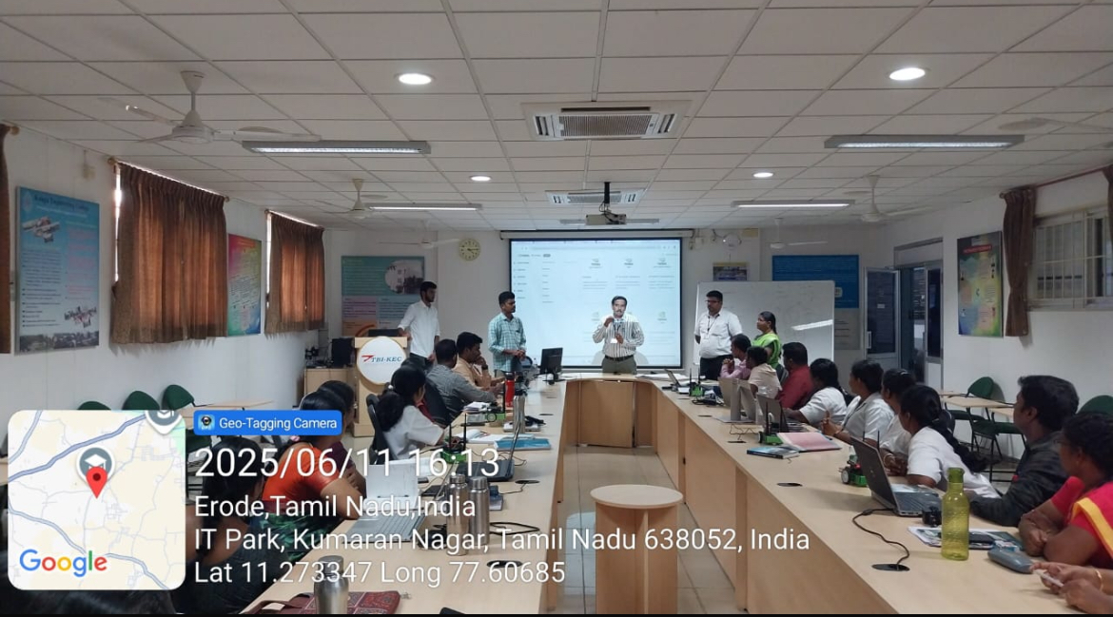

1.2 Training on NVIDIA Jetbot Edge Device.
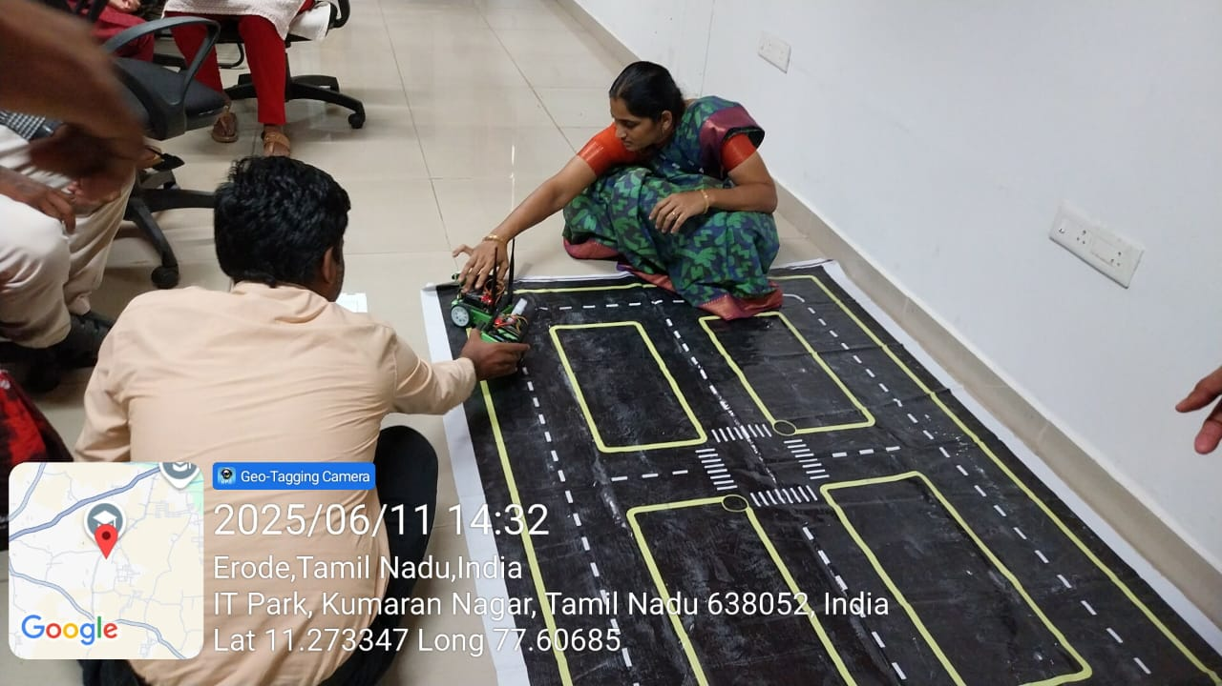

1.3 Drive Link:
https://drive.google.com/drive/folders/1g4qTiFBbrJrtLfbX9KUKJOX8bYl-EHPt?usp=drive_link

- Vellore Institute of Technology, Vellore Campus

  - Faculty Development Training on NVIDIA Frameworks

NVIDIA Autonomous Vehicle using Jetbot Deployment
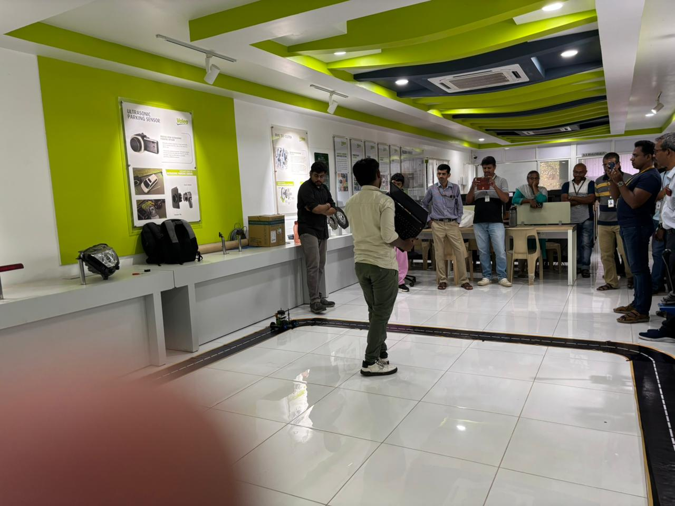
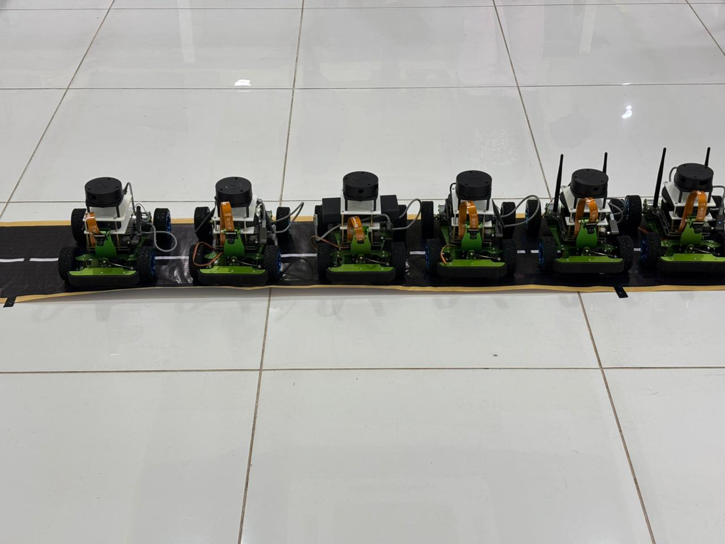
  - Faculty Development Training on Video Analytics using NVIDIA Frameworks:

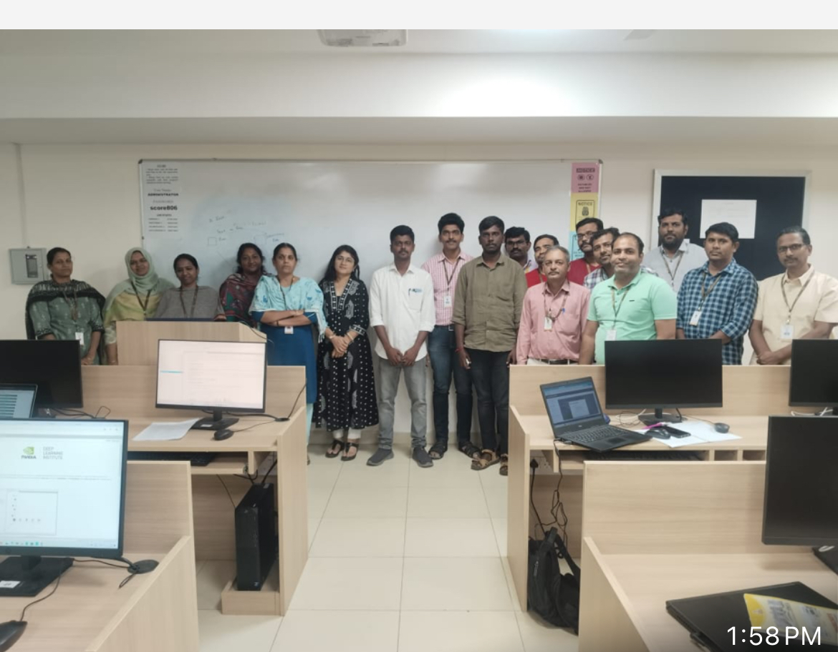

Drive Link:
https://drive.google.com/drive/folders/16IguWqXdIoKTV23a1He1wO5HxJ1qvHiw?usp=drive_link

